Name:

PHY 1048L Physics Laboratory I

L2: Measurement and Error Analysis (enter units in blank parentheses)
- Coin
Table 1
Digital Micrometer | Deviation
Diameter( ) | |xi-average| ( )

Table 2
 |  | Digital caliper | Deviation ( )
 |  | Diameter ( ) | |xi-average|
 | 1 |  |  |  | 1
 | 2 |  |  |  | 2
 | 3 |  |  |  | 3
 | 4 |  |  |  | 4
Average ( | )= |  |  | Average ( | )=
σ( | )= |  |  | σ( | )=
% error= |  |  |  | % error=

Note: The computer spreadsheet program knows nothing about significant figures. You may need to adjust the cell formats to display more or less digits than the default display.

- Diameter of Hair Sample -- OMIT
- Thickness of a sheet of paper
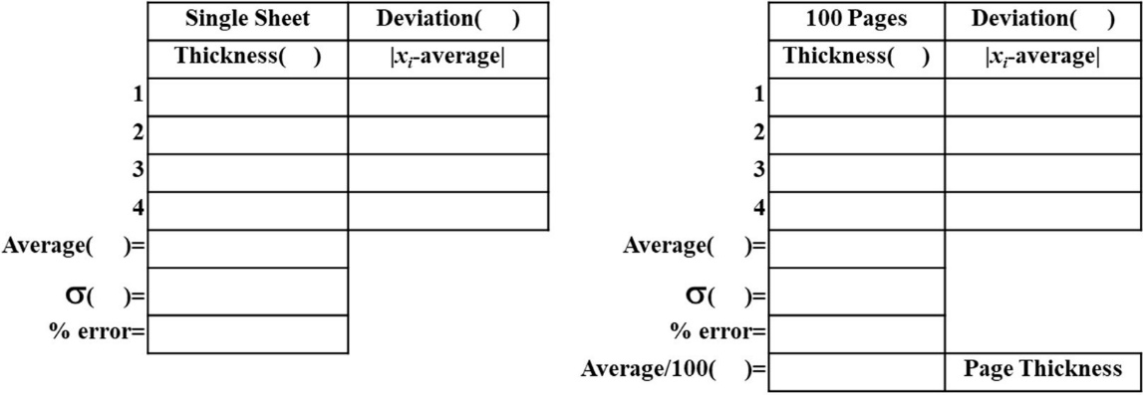

- Volume of soda can (𝒎^{𝟑})
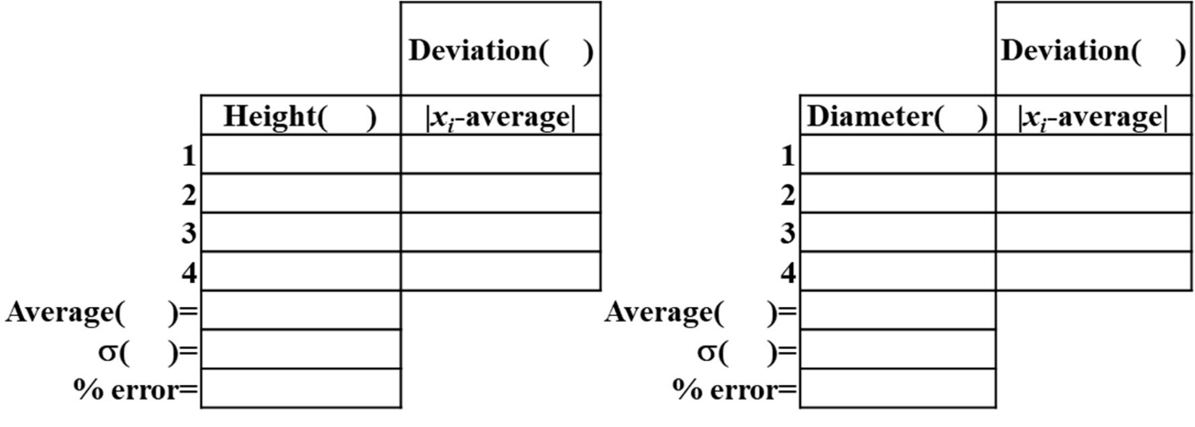
Volume of Cylinder= ( ) % Error= σ_{v}= ( )

- Density of Water (𝒌𝒈/𝒎^{𝟑})
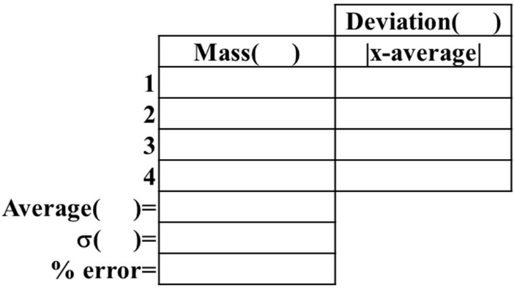
Density of Cylinder= % Error= σρ=

- There is a ‘Measurement and Analysis’ spreadsheet on Canvas. Enter your data into this table, each group member should save a copy of the results to be submitted into the DropBox on Canvas, with your lab report by the due date.

- In your report, please focus on summarizing the results; don't list every measurement.
  - Ask yourself what the point was for each section of the lab.
    - For example, what do you conclude about the capabilities of the digital micrometer versus digital caliper after comparing the two-coin diameter measurements?
    - How well do you think a digital micrometer measure something as small as a single hair?
    - What limits its capability?

    - Why measure one versus 100 sheets of paper?
    - Also, consider your results in light of what you expected, e.g., did the density of the can of water come out close to that for water?
    - How did your computed volume match that claimed on the can?
Note that in reporting results, if you measure V to be 43.6678 cm3 with a standard deviation of 0.0524 cm3 and a percent error of 0.12%, you should report this as V = 43.67+/-0.05(0.12%) cm3. This is the standard format for reporting results, i.e., value + standard deviation (% error); don’t forget units.

Be sure to talk about the significance of your observations, problems you encountered, and sources of errors.
Explain each error source, classify it as random or systematic, and quantify it in terms of its impact on your result for each part of the lab.

